-[Web data extraction Requirement document

Suggested Code Policy:

1. Copy the Project folder structure from bellow github link.

<https://github.com/pool23/pool_UK>

1. Use Python(Mandatory) with BeautifulSoup, Scrapy and Selenium (Feel free to use any other Python libraries)
2. Store Scrapped data with provided file name and CSV format.

Work 1:

**Scarped Data Format (File Name - CoOp_Data_Deposit_<YYYY_MM_DD>.csv)**

|  |  |
| --- | --- |
| **Column NAMES for Deposits** | **Default Values** |
| Date | Date(YYYY-MM-DD) |
| Bank_Native_Country | UK |
| State | London |
| Bank_Name | The Co-operative Bank |
| Bank_Local_Currency | GBP |
| Bank_Type | Bank |
| Bank_Product | Deposits |
| Bank_Product_Type | SCRAPED DATA - Format should be Savings/Current/Term Deposits |
| Bank_Product_Name | SCRAPED DATA |
| Min_Opening_Bal | SCRAPED DATA |
| Balance | SCRAPED DATA |
| Bank_Offer_Feature | Offline by default and Online where product name has keyword Online |
| Term in Months | SCRAPED DATA |
| Interest_Type | SCRAPED DATA - Default is Variable, if data is not available in product name |
| Interest | SCRAPED DATA |
| AER | SCRAPED DATA |
| Bank_Product_Code | LEAVE THIS COLUMN BLANK |

[**https://www.co-operativebank.co.uk/savings/interest-rates**](https://www.co-operativebank.co.uk/savings/interest-rates)

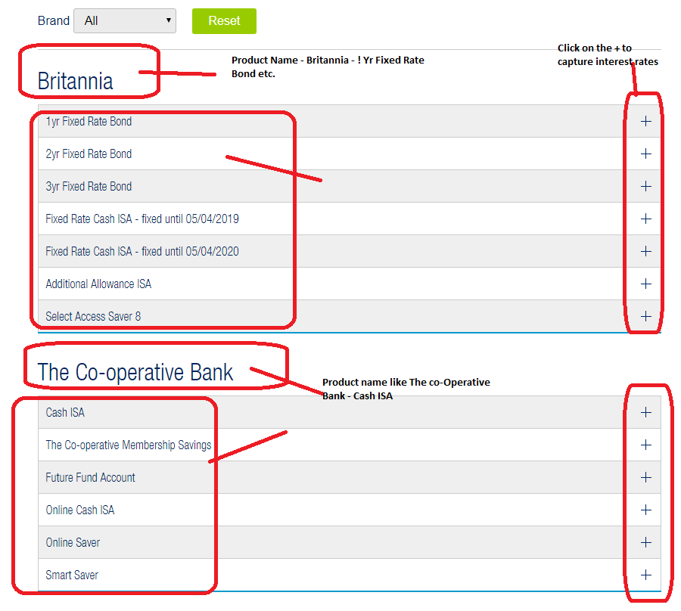

**Please update product feature Online, wherever product_name has Online in its name**

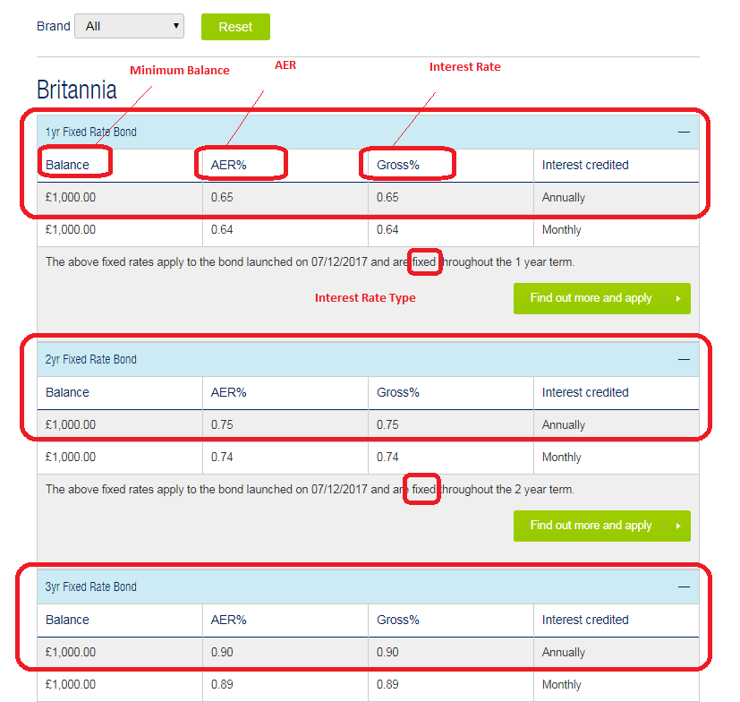

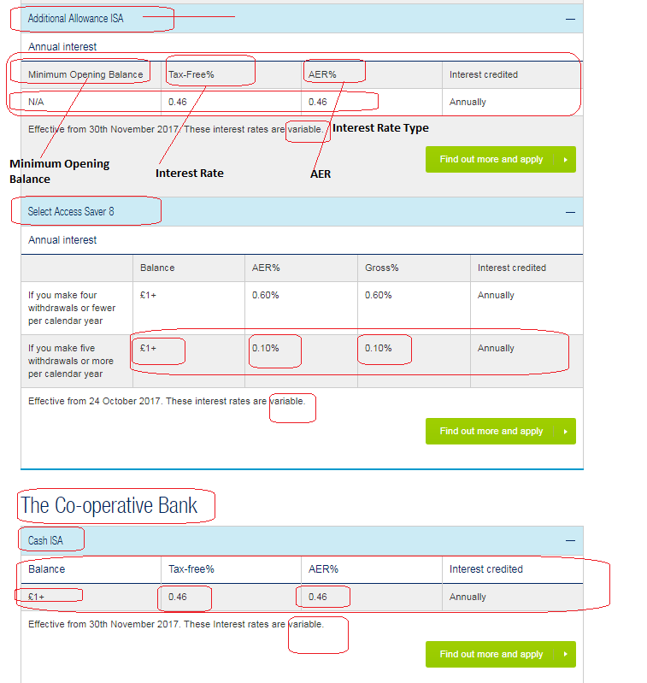

[**https://www.co-operativebank.co.uk/currentaccounts/compare-current-accounts**](https://www.co-operativebank.co.uk/currentaccounts/compare-current-accounts)

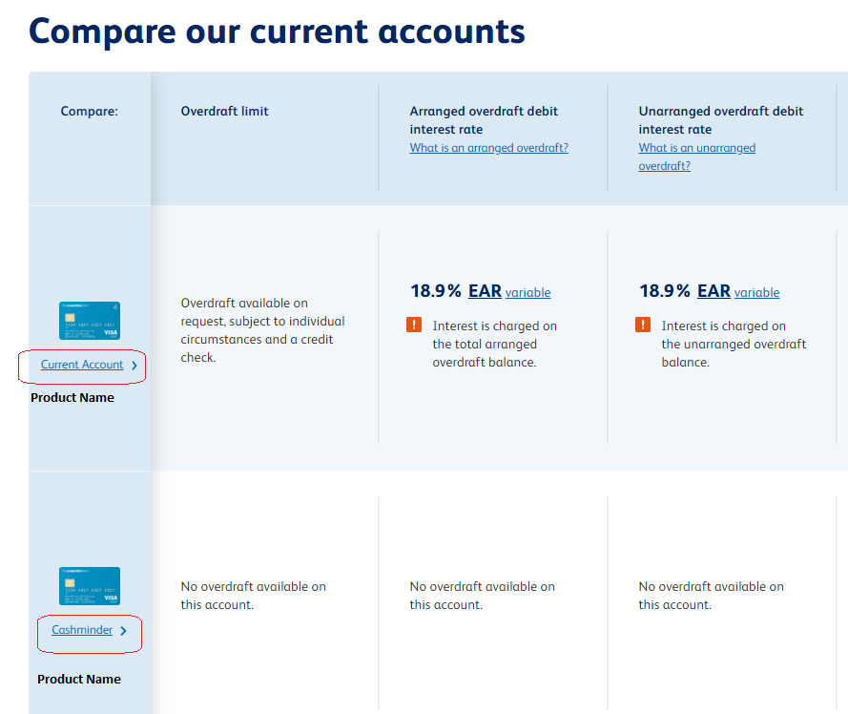

Work 2: Mortgage Rates

**Scarped Data Format (File Name - CoOp_Data_Mortgages_<YYYY_MM_DD>.csv)**

|  |  |
| --- | --- |
| **Mortgages Columns** | **Default Values** |
| Date | Date(YYYY-MM-DD) |
| Bank_Native_Country | UK |
| State | London |
| Bank_Name | The Co-operative Bank |
| Bank_Local_Currency | GBP |
| Bank_Type | Bank |
| Bank_Product | Mortgages |
| Bank_Product_Type | Mortgages |
| Bank_Product_Name | SCRAPED DATA |
| Min_Loan_Amount | SCRAPED DATA |
| Bank_Offer_Feature | Offline |
| Term (Y) | SCRAPED DATA |
| Interest_Type | SCRAPED DATA |
| Interest | SCRAPED DATA |
| APRC | SCRAPED DATA |
| Mortgage_Loan_Amt | SCRAPED DATA |
| Mortgage_Down_Payment | 100% - <Loan to Value Col%> |
| Mortgage_Category | New Purchase |
| Mortgage_Reason | Primary Residence |
| Mortgage_Pymt_Mode | Principle + Interest |
| Fixed_Rate_Term | SCRAPED DATA <from title> |
| Bank_Product_Code | LEAVE THIS COLUMN BLANK |

<https://www.co-operativebank.co.uk/mortgages/existing-customers-moving-rates>

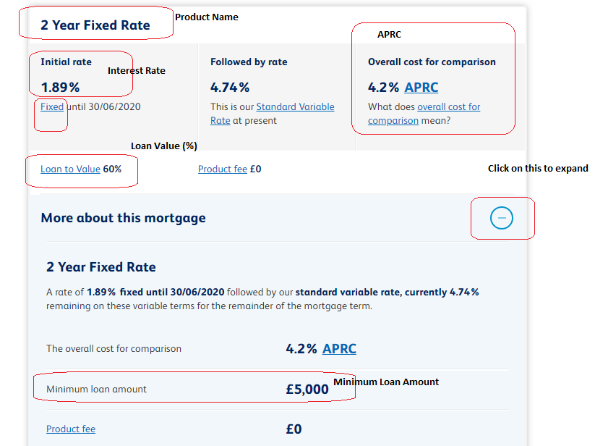

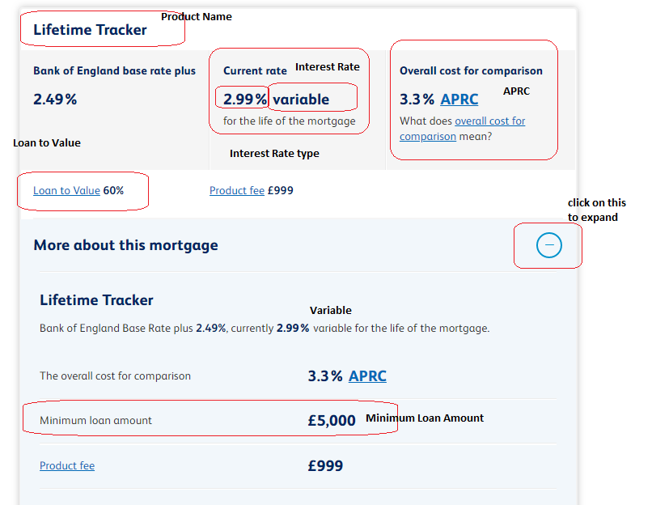

Ignore below snapshot

